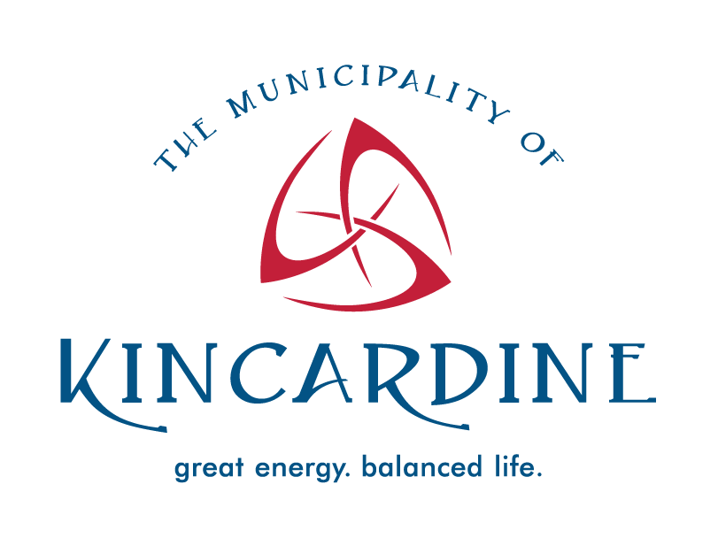
Municipality of Kincardine

Council Info

January 10, 2024

The following is a summary of major discussion items presented at Council on January 10, 2024. Please refer to the website for the complete and official records of the meeting including consent agenda items, motions of Council, communications, detailed reports, and attachments.

You can watch Council meetings live on the Municipality of Kincardine's YouTube Channel or on Rogers TV Channel 6. Recordings will be available on demand on our YouTube Channel or at www.rogerstv.com following the meeting. Council is also broadcasted live on Bruce Telecom TV.
Visit our website at www.kincardine.ca or follow us on social media to receive updates on Council meetings.

Council meeting

Matters for Public Participation

Delegations and Presentations
Front Ending Or Cost Sharing Agreements
As part of the Municipality's legal counsel, David M. Woodward from Lerners Lawyers provided an information presentation.

Bruce Energy Centre
Nancy Michie made a presentation on portable water supply for the Bruce Energy Centre Industrial Park and 1554 Bruce Road 23.

Bruce County Library
Brooke McLean provided an update on the Bruce County Public Library.

Kincardine Police Services Board
Stellina Williams, Sandy Donald and Inspector Wilcox provided a Kincardine Police Services Board update.

Matters for Discussion and Direction

Staff Reports

Engineering Request for Proposal, OP-2024-01
The current engineering contracts were set to expire in December of 2023; the Infrastructure and Development team undertook a Request for Proposals (RFP) process for Engineering Services. In order to reach a broader scope of potential firms the RFPs were advertised and managed through the online Bids and Tenders e-procurement platform. The details of the results are provided in this report.

Council awarded the Engineering Services Contracts to BM Ross and Associates and GM BluePlan Engineering Ltd. as detailed in report in Report OP-2024-01.

Vanderveeken Mutual Agreement Drain, Environmental Services-2024-03
In 2022, a request was made under Section 2 of the Drainage Act and requested to the Municipality for consideration. This request was forwarded to the Drainage Superintendent for review and determination of boundaries and watershed area. This process indicated two private property owners who would benefit from the drainage works, and the Municipality of Kincardine as well. The process of starting a Mutual Agreement Drain commenced which concluded in December 2023.

Council accepted the Mutual Agreement Drain (MAD) report as provided and passed a By-law to authorize the agreement.

Heritage Kincardine – Terms of Reference Update, Legislative Services-2024-01
With the recent Governance Review and update to the Committee policies, the Heritage Kincardine Terms of Reference was reviewed and updated with the new format. The committee composition was reviewed with two changes proposed: to add a member of Council to this Committee, as this is the only Committee without Council representation; and to reduce the number of members overall.

Council passed a By-law to approve the updated Terms of Reference for Heritage Kincardine; and
appointed Mike Hinchberger to sit as a Council member and Chair on Heritage Kincardine.

Motions

Appoint Acting Clerk
The Chief Administrative Officer Jillene Bellchamber-Glazier was appointed as Acting Clerk, when necessary for the Clerk to leave the meeting, for the purpose of taking minutes for the January 10, 2024 closed and open meetings.

Bluewater District School Board Request for delegation
Council directed staff to invite a delegation from the Bluewater District School Board next month to provide an update to Council on the status of the future high school.

Consideration of By-laws

2024 Interim Taxation By-law
The purpose of this By-law is to request that Council adopt the 2024 Interim Taxation By-law in order to establish the instalment dates for payment of property taxes, and to issue tax bills to provide the necessary cash flow required for municipal operations.

The “2024 Interim Taxation By-law” was passed.

Current Operating Borrowing By-law
The purpose of this By-law is to request that Council authorize the temporary borrowing of money until the taxes are collected and other revenues received in order to meet the current expenditures of the Municipality for 2024.

The “Current Operating Borrowing By-law” was passed.

Appoint By-law Enforcement Officers (Municipal Support Services Inc.) 2024 By-law
The purpose of this By-law is a housekeeping update for the officers appointed as By-law Enforcement Officers in the Municipality of Kincardine.

The “Appointment By-law Enforcement (Municipal Support Services Inc.) 2024 By-law” was passed.

Amend Code of Conduct for Members of Council, Local Boards and Committee Members Policy (1) By-law
The purpose of this By-law is to amend the Code of Conduct with Principles Integrity as the Integrity Commissioner. The “Amend Code of Conduct for Members of Council, Local Boards and Committee Members Policy (1) By-law” was passed.

Matters for Information

Consent Agenda

Items listed under the Consent Agenda are considered routine and are enacted in one motion as a Matter Arising. The exception to this rule is that a Council member or the Chief Administrative Officer may request one or more items to be removed from the consent agenda for separate discussion and action.

Statistical and Information Reports

Recommendation: Receive and file statistical reports.
Infrastructure and Development 2023 – 4th Quarter, Infrastructure Development Quarterly Report-2024-01

Environmental Services Compliance Report December 2023, Environmental Services-2024-01

Kincardine By-law Service Report November 2023

CAO Department 2023 Q3 and Q4 Update, CAO General-2024-01

Closed Session

Mayor Craig reported that Council held a closed session pursuant to Section 239 (2) of the Municipal Act, 2001. In the closed session they approved the closed minutes of December 13 and December 18, 2023, and received for information only the CAO Performance Evaluation (Personal matters about an identifiable individual, including municipal employees),and a report regarding the Application for Union Certification Update (Labour relations or employee negotiations).
In addition, Council provided direction in the closed session regarding the Review of Municipal Reorganization (Labour relations or employee negotiations). They also directed staff to place a by-law on the open meeting agenda regarding the disposition of land at 199 Lambton Street.
In open session, the “Emmerton Agreement of Purchase and Sale By-law” was approved with proceeds from the sale being allocated to the Affordable Housing Fund 15.

