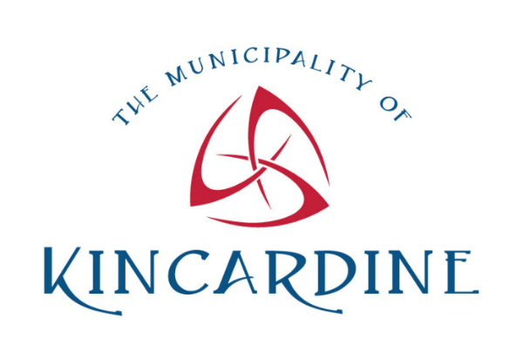


What is Hinduism?
Overview
The Municipality of Kincardine is committed to improving inclusion, diversity, equity and access (IDEA) within our organization and within the community. Part of this work involves getting to know one another and becoming more aware of customs and celebrations shared by our colleagues, our customers and our community. Learning the history and developing an understanding of different cultures and religions in our community helps us become aware, rethink any assumptions and better understand the similarities in traditions.
Core Beliefs
Hinduism also know as Sanatan Dharm, one of the world's oldest religions, is a complex and diverse tradition that originated on the Indian subcontinent over thousands of years ago.
Unlike many other major religions, Hinduism does not have a single founder, scripture, or set of dogmas. Instead, it encompasses a wide range of beliefs, practices, philosophies, revere other religions and not look to convert.
Hinduism is characterized by several core concepts, including Dharma (duty/righteousness), Karma (the law of cause and effect), and Samsara (the cycle of rebirth). Hindus believe in Brahman, the ultimate, unchanging reality that exists beyond the physical world and manifests in various deities like Vishnu, Shiva, and Devi. These deities represent different aspects of the divine and are revered in different ways, reflecting the diversity within Hindu practices.
Hindu practices vary widely but often include rituals, festivals, meditation, yoga, and temple worship. Sacred texts like the Vedas, Upanishads, Bhagavad Gita, and Ramayana provide guidance on spiritual and moral conduct.
Today, Hinduism is predominantly practiced in India and Nepal, but it has a global presence due to migration. It continues to influence cultures and spiritual practices worldwide, with an estimated 1.2 billion adherents.
Sacred Texts
Hinduism’s vast collection of sacred texts includes the Vedas, the oldest scriptures written in Sanskrit, and the Upanishads, which explore the philosophical aspects of the faith. Other important texts include the Ramayana and the Mahabharata, epic narratives that offer moral and spiritual lessons, and the Bhagavad Gita, a dialogue between Prince Arjuna and the god Krishna that discusses duty and righteousness.
Festivals and Rituals
Festivals play a crucial role in Hindu culture, marking significant religious and seasonal events. Diwali, or Dipawali is the Festival of Lights, and is one of the most widely celebrated festivals, symbolizing the victory of light over darkness and good over evil. The festival gets its name from the row (avali) of clay lamps (deep) that Indians light outside their homes to symbolize the inner light that protects from darkness. Joyous Holi, the Festival of Colors, celebrates the arrival of spring and the triumph of good over evil. Diwali and Holi will be celebrated on Nov 1, 2024 and Mar 14, 2025, respectively. These festivals are based on a lunisolar calendar, so their dates vary each year [1].
Global Presence and Influence
While Hinduism originated in India, it has spread globally, particularly in countries like Nepal, Sri Lanka, Caribbean, Bangladesh, and Indonesia, and among the Indian diaspora in countries like Canada, USA and UK. In Canada, Hindu communities actively participate in preserving and promoting their cultural and religious heritage, celebrating festivals, building temples, and educating others about the faith and contributing to Canadian Mosaic.
Through its teachings on karma, dharma, and the cyclical nature of existence, Hinduism provides profound insights into the human experience, making it a religion that continues to inspire and guide millions around the world.
Interesting Facts About Hinduism
- Hindus believe in one God as Paramatma or Brahman, which can manifest into many forms. As this God is formless and omnipresent, they are free to worship God in any form, including cows, rivers and deities.
- Hinduism is believed to be the world’s oldest living religion and teaches spirituality and way of life.
- Hindus believe they are born as divine beings and that all humans are the embodiment of truth, consciousness and bliss (one soul), and their life goal is moksha (liberation from Samsara).
- Hindus believe in karma and reincarnation, and the wisdom of Vedas.
- “Om” or “aum” is known as the sound of the universe, and is the most sacred sound and symbol of Hinduism.

Did you Know?
- Popular games including Chess, Snakes and Ladders and Polo were created by ancient Hindus.
- Yoga and meditation originated in India and is one of Hinduism’s most significant contributions to world civilization.
- “Namaste” (pronounced na-mas-TAY) is a greeting where palms are held together in a prayer position and the head is bowed slightly. It means “the divine in me bows to the divine in you,” in Sanskrit, a sacred language.
Sources
- history.com - Hinduism - Origins, Facts & Beliefs
- britannica.com - Hinduism | Origin, History, Beliefs, Gods, & Facts
- bbc.co.uk - Religions - Hinduism: At a Glance
- britannica.com - Hinduism - Kids
- https://sanatancentre.com/
For more information:
The Municipality of Kincardine https://www.kincardine.ca/live-here/inclusion-diversity-equity-and-access-idea/
Or contact Lorie Fioze: 519 396-3468 lfioze@kincardine.ca

